Force Default Preferences

# Overview:

The purpose of this class is to allow administrators to force users to use preferences defined for them in the CMC. It will check the box “Use Default Settings (Administrator defined)”.

JAR File Name:

* ForceDefaultPreferences.jar
  + Sets the above mentioned option on selected users

Class to Run Value:

* com.dft.boetools.programs.ForceDefaultPreferences

# Tool Workflow:

The basic logic followed by the tool is as follows.

1. Retrieve list of Users based on parameters passed in at runtime,
2. Check the above mentioned box
3. Save the user

# Parameters

All program parameters are passed to the Program object as command line variables. This means we are limited to space separated tokens. To work around this and to avoid a dependency on parameter order we pass all parameters as Name=Value pairs. Because space is the token separator we must quote any Name=Value token which contains a space as part of its data.

Example:

PARAMETER_NAME=A_VALUE_WITHOUT_SPACES

Or

“PARAMETER_NAME=A VALUE THAT CONTAINS SPACES”

|  |  |  |
| --- | --- | --- |
| Parameter Key | Optional / Required | Description |
| USER_GROUPS | Optional | This parameter allows the administrator running the program to Specify the users who will be manipulated by groups. The parameter value can be a comma separated list of User Group names. Users who are direct members of one or more of these groups will be affected (Note users must be direct members of the group). This parameter has a default value of "Everyone".  Example Usage:  USER_GROUPS=Everyone |
| USERS | Optional | This parameter allows the administrator running the program to specify a specific set of users who will be manipulated. The parameter value can be a comma separated list of User Names. Users who are explicitly listed in this parameter will be affected. This parameter can be used in conjunction with the USER_GROUPS parameter. If both are specified the Super Set of users between the parameters will be affected. I.E. You can specify a USER_GROUP  To get all the users in that group plus you can specify several additional Users outside that group that will also be affected.  Example Usage:  USERS=rwells |
| EXCLUDED_USERS | Optional | This parameter allows the administrator running the program to specify a specific set of users to exclude from the operation regardless of the other parameters values. The parameter value can be a comma separated list of User Names.  For example you can specify a group of users to include with USER_GROUPS and omit a subset of users from that group by specifying those user names in this parameter  Example Usage:  EXCLUDED_USERS=Administrator,Guest |
| NEW_USERS_ONLY | Optional | This optional Boolean parameter defaults to false. If set to true only users who have a creation date that is more recent than the last runtime for this program will be included in the manipulation performed by this program. If set to true you must also provide the additional parameter JOB_NAME which should be set to the name given to this program object in the CMC so that we can locate the most recent successful instance of the program.  Example Usage:  NEW_USERS_ONLY=true |
| JOB_NAME | Optional | This optional parameter is necessary if you set NEW_USERS_ONLY to true. As described above, it should be set to the name of the program in the CMC so that the last Run Time can be determined. If not specified a default value for the last runtime will be used. This will be JAN 1st 1970.  Example Usage:  JOB_NAME=ForceDefaultPreferences |

# Logging Output

The programs will output verbose logging describing what is happening as the program runs.

# Installation and Deployment

Like all Business Objects Programs the tool is delivered as a Java JAR file. This JAR file must be deployed to the Business Objects System via the Central Management Console (CMC). Follow the steps below for deployment.

Once deployed, you can use the standard Business Objects scheduling features to run the program either interactively or on a recurring basis. Make sure you set appropriate limits on History so that you don’t pollute your system with unnecessary historic instances.

Program output is available for each job instance as a plain text file.

1. Logon to CMC as an Administrator.
2. Select a Secured Folder where you will store the Program Object. For Example a folder named Admin Tools which only the Administrator Group can access.
3. Navigate to ***Manage Menu – Add – Program File***
4. You will be taken to the ***Program File deployment Wizard***. 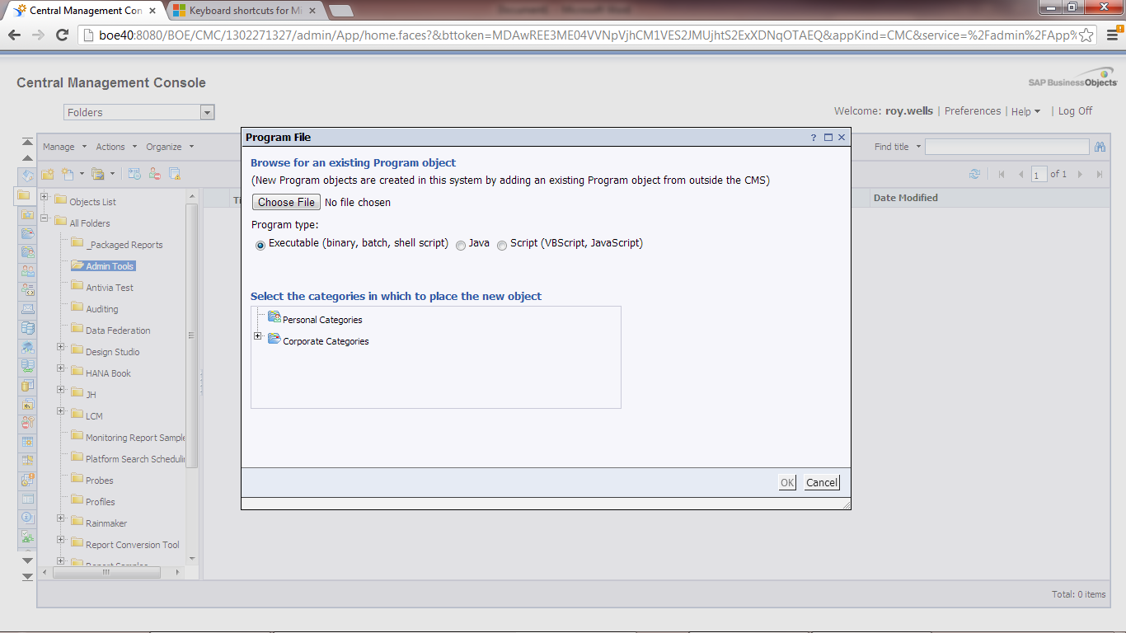
5. Click ***Choose File***, and select the location where you have downloaded the JAR file.
6. Click the ***Java*** radio button.
7. Click ***ok.***
8. The Program Object is created with the same name as the JAR File.
9. Before the tool can be scheduled there are additional configuration steps that must be applied.
10. Open the objects properties using the right click action on the object.
11. From the Properties window expand ***Default Settings***
12. Select ***Program Parameters.*** You will be taken to the Parameter Configuration Screen. 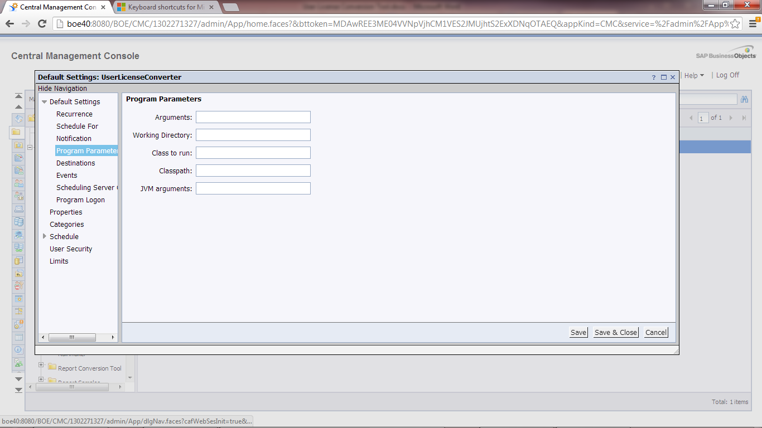
13. On this screen in the ***Arguments*** field we will configure any program arguments using the parameters defined in the Parameter section of this document.
14. In the Class to run field we will enter the name of the class that contains our Program implementation see the Class to Run Value from the Overview in this document.
15. Click Save & Close
16. Your program is deployed and ready to run.